National Fish and Wildlife Foundation

Gulf Environmental Benefit Fund

Quarterly Progress Report

Easygrants ID: 65905

Project Title: Apalachicola Bay Oyster Restoration-Phase II (FL)

Organization: Florida Fish and Wildlife Conservation Commission

Project Term: 1/1/2020 – 12/31/2025

Reporting Period: 7/1/2023 – 9/30/2023

1) For the applicable quarter, provide an update on the individual Tasks comprising the Project, including for each Task a summary of:

(i) the Work performed on such Task during the reporting period;

(ii) progress made toward Task milestone(s) and/or deliverable(s) as measured against the Task schedule;

(iii) performance of the Task as against the applicable Task Budget; and,

(iv) any existing or anticipated problems with implementation of the Task; any defects, deficiencies, or delays in the Task Work (including but not limited to the disclosure of any factors that are likely to impact the Project schedule or any Task schedule); and any remedial action(s) planned or already taken with respect to any defects, deficiencies, or delays affecting the Task.

**\*Note\*** For each task that has not yet begun, be sure to identify when work is anticipated to begin and briefly explain why work has not commenced.  If work on a task is delayed, please explain how this may or may not impact the overall project timeline. For each task that is complete, identify when the task was completed and provide a brief description of the associated milestone(s) and/or deliverable(s).

**Task 1 – Data Collection**

1. *Apalachicola Bay:*

FWC continues to meet regularly with project partners at Florida State University’s ABSI program, subject matter experts (SME) from Apalachicola. We continue to routinely coordinate and meet with project partners and SMEs throughout the project area.

Over the last quarter, data workflow underwent a transition from the existing Excel worksheet-based storage to a new SQL-based storage solution. The transition has included a new protocol to simplify and unify state-wide oyster data entry and quality assurance. Implementing the new workflow has meant a delay in the usual speed of data entry as we worked with our Office of Information Technology to test and fix bugs in the new system. Training staff on the new system has also contributed to data entry delays. Data presented may contain gaps and should be treated as preliminary as it has not been subjected to the full QA/QC process.

Monthly oyster recruitment monitoring was conducted at 15 stations throughout Apalachicola Bay (Fig. 1) with three replicate spat traps deployed at each station. Recruitment was estimated as described in the Scope of Work for Task 1. Sediment traps (four replicate PVC cups measuring 3-inch diameter x 8-inch height) were deployed at six stations in Apalachicola Bay monthly (Fig. 1). The dry weight of the contents was recorded, and any sediment traps retrieved with large biota inside were excluded from analysis.

Semi-annual oyster surveys associated with Task 1 were conducted in May and June 2023. These surveys are the continuation of surveys completed as part of NFWF GEBF #40623. At each of the seven stations, samples were collected from each of one or two parcels. Two stations include parcels cultched in 2015 with 300 and 400 cubic yards per acre (Bulkhead and Hotel), referred to as Previously Cultched. Two stations include parcels which received cultch material in July 2021 (Lighthouse and East Lumps), referred to a Recently Cultched. One station (Cat Point) includes two parcels, one of which received cultch material in July 2021 (Recently Cultched), while the second received no cultch material, referred to as Uncultched. The remaining stations each have one parcel (Uncultched) (Fig. 1). At each parcel, fifteen replicate ¼-m2 quadrats were randomly deployed and all oysters and cultch material within each quadrat were collected for analyses. Analyses included determination of the total number of live oysters and of dead oysters with articulated shells, shell height (SH=maximum linear distance from the umbo to the ventral shell margin) measurements for all live and dead oysters, and substrate volume and weight (dead oysters with articulating valves plus single shell material). Samples were sorted into live oysters, oyster shell, cultch, shell hash, and black & other substrate. The weight and volume were measured for each of these categories. The number of oyster drills (*Stramonita floridana*) were also counted for each quadrat.

Temperature, salinity, dissolved oxygen concentration, pH, turbidity, and water depth were recorded during all field sampling.

*Suwannee Sound:*

Monthly oyster recruitment monitoring was conducted at 12 stations in Suwannee Sound (Fig. 2). Three replicate spat traps were first deployed at each station in January 2022, and traps have been retrieved and redeployed monthly. Recruitment was estimated as described in the Scope of Work for Task 1.

Starting in June 2023, oyster shell budget model surveys associated with Task 1 will be carried out on a semi-annual basis during the summer (June – August) and winter (November – January) periods. These shell budget surveys will be conducted at fixed stations on subtidal and intertidal reefs in areas that are seasonally open to oyster harvest (termed a “fishery effects location”) and in areas that are permanently closed to oyster harvest (serving as a “control location”) (Fig. 3).

During the past quarter, field staff established 2 “fishery effect” and 2 “control” locations – one subtidal and the other intertidal – each containing 6 fixed stations and completed sampling for the summer (June – August) shell budget survey (Fig. 3). Sample processing should be completed, and preliminary data should be available for the next quarterly report.

On August 30th, Hurricane Idalia made landfall north of Suwannee Sound near Keaton Beach as a strong category 3 storm. Preparing for and recovering from the storm has caused some delays in field work and sample processing. A total of 15 shell budget stations (6 subtidal fishery effect, 6 subtidal control, and 3 intertidal fishery effect stations) were sampled before Idalia. To assess impacts of the storm on shell budget, these stations were sampled again in September. Analysis of this data should be available for the next quarterly report.

Temperature, salinity, dissolved oxygen concentration, pH, turbidity, and water depth were recorded during all field sampling activities.

Data for Suwannee Sound is being entered and checked for quality assurance using the new SQL-based system developed for state-wide oyster data. Therefore, data presented may contain gaps and should be treated as preliminary as it has not been subjected to the full QA/QC process.

1. *Apalachicola Bay:*

The data reported in this section is preliminary as it has not been subjected to the full QA/QC process.

Preliminary recruitment data is available through the end of August 2023. Recruitment rates ranged from 0 to 2.2 spat per shell in the last quarter. The maximum rate of 2.2 was observed at Station 14 during sampling in August 2023 (Fig. 4).

Preliminary sediment trap data is available through the end of September 2023. Sediment rates ranged from 4.5 to 331.6 grams (dry weight) of sediment in the last quarter. The maximum rate of 331.6 was observed at Station 13 during sampling in September 2023 (Fig. 5).

Preliminary shell budget data is available through the end of June 2023.

Live oysters were present at all stations in the most recent samples (Fig. 6). Mean oyster densities ranged from 2 oysters/m² at SBM Normans 8 to 373 oysters/m² at SBM East Lumps 10. Mean densities were generally highest at stations which were recently cultched (Lighthouse, East Lumps, and Cat Point).

Live oyster shell height means ranged from 12 to 78 mm (Fig. 7) and an overall average shell height of 42 mm. There were 1990 oysters larger than 30 mm measured (84.2% of total measured), and there were 575 oyster of legal harvest size (SH>=76 mm) measured (24.3% of total measured) during this quarter.

Dead oysters were collected at most stations. Dead oyster shell heights averages ranged from 28 to 67 mm (Fig. 8) and the overall average shell height of dead oysters was 45 mm.

No oyster drills (*Stramonita* *floridana*) were found at any station this quarter. Mean oyster drill densities were very low ranging from 0 to 0 oyster drill/m² (Fig. 9).

Substrate weights were measured for all parcels (Figure 10). Substrate weights were highest at stations which were recently cultched (Lighthouse, East Lumps, and Cat Point). The main substrate components accounted for 98.9% of total weight which were: cultch (30.1% of total weight), shell hash (21.5% of total weight), live oysters (37.6% of total weight) and oyster shell (9.8% of total weight). Proportions of substrate components differed between parcels with shell hash and cultch being the predominant substrate types (Figure 11).

Figures 12 – 15 provide a closer examination of the data from the 2021 restoration areas (Cat Point, East Lumps, and Lighthouse). Fig. 12 shows the increase in mean shell heights measured since the restoration effort. In contrast, the mean shell heights in areas without restoration efforts have changed little since 2021. A large recruitment event was observed in the first survey after restoration material was deployed resulting in very high oyster densities (Fig. 13). Overall densities have decreased since 2021 as spat have grown into larger, and even legal size (>75 mm), oysters (Figs. 13 – 14). The components of the restoration areas have also changed over time (Fig. 15). Before restoration, there were only small amounts of substrate, primarily shell hash. Immediately after restoration (Summer 2021) there has been notably more substrate dominated by planted cultch material. Over 2022 and 2023 the amount and proportion of live oyster and oyster shell has increased notably. Hopefully, this is a sign of a self-sustaining system, though it should be noted that the major stressors for the system have been largely absent: environmental conditions have been stable; natural predators, primarily oyster drills, have been largely absent; and there has been a moratorium on oyster harvest in Apalachicola Bay since 2020. How the system would respond to any of those stressors returning is currently unknown.

Preliminary water quality data is available through the end of August 2023. Water temperature, salinity, dissolved oxygen concentration, pH, water depth and Secchi depth were recorded during sampling (Figs. 16 – 20). Over the past quarter, water temperatures ranged from 28.2 to 32°C; Salinities ranged from 10.4 to 35.9; dissolved oxygen ranged from 4.4 to 8 mg/L; pH values ranged from 7.8 to 8.2; and secchi penetration values (percentage of the water column through which the Secchi disk could be seen) ranged from 14.3 to 75%.

*Suwannee Sound:*

The data reported in this section is preliminary as it has not been subjected to the full QA/QC process.

Preliminary recruitment data is available through the end of May 2023. Recruitment rates ranged from 0 to 141.2 spat per shell in the last quarter. The maximum rate of 141.2 was observed at Station 8 during sampling in May 2023 (Fig. 21).

Preliminary water quality data is available through the end of May 2023. Water temperature, salinity, dissolved oxygen concentration, and pH were recorded during sampling (Figs. 22 – 25). Over the past year, water temperatures ranged from 11.8 to 28.2°C; Salinities ranged from 4.3 to 32; dissolved oxygen ranged from 6 to 12.8 mg/L; pH values ranged from 6.8 to 9.6.

1. All budget expenditures related to this Task were performed as scheduled.
2. Over the last quarter, data workflow underwent a transition from the existing Excel worksheet-based storage to a new SQL-based storage solution. The transition has included a new protocol to simplify and unify state-wide oyster data entry and quality assurance. Implementing the new workflow has meant a delay in the usual speed of data entry as we worked with our Office of Information Technology to test and fix bugs in the new system. Training staff on the new system has also contributed to data entry delays. Data for the current quarter is not currently available. However, we should be able to clear the backlog by next quarter’s report.

**Task 2 – Stakeholder-informed Management Options**

1. FWC has continued to leverage the facilitation process of ABSI to gather stakeholder input on future management options for Apalachicola Bay. FWC staff continue to attend ABSI community advisory board (CAB) meetings and play an integral role in keeping the CAB informed of this program’s progress. There were two ABSI CAB meetings during this reporting period, August 9 and September 27, at which the FWC program manager provided an update on the NFWF-related work. Updates will continue to be provided at all future meetings. Additional items discussed at the meeting were: a review of the ABSI Restoration and Management Plan Framework, an open discussion led by the Community Outreach Subcommittee on outreach and messaging strategies, and initial discussions by the Successor Group Subcommittee. Ed Camp and the University of Florida (UF) also continues to coordinate with the ABSI group and provide input as needed.

FWC program staff also attended a community workshop held by ABSI on August 9, 2023. This event was less formal than the ABSI CAB meetings, and allowed for much more one-on-one interactions between scientists and public stakeholders. FWC program staff discussed short- and long-term restoration proposals, as well as potential management strategies for the Apalachicola Bay oyster fishery.

ABSI will be concluding at the end of this calendar year. A successor group, tentatively named Partners for a Resilient Apalachicola Bay (PRAB), will work to organize stakeholders committed to working collaboratively for the long-term and to ensure that the restoration and management plan is implemented, monitored, and adaptively managed over time and has the support of the community. FWC has been requested to serve as an advisory member. It is expected that Devin Resko, PI for this grant #65905, will serve as FWC’s representative. It will allow for continued communication on stakeholder feedback regarding the local oyster fishery.

The sub-contract with UF, spearheaded by Ed Camp, continued to progress. UF has continued to hold stakeholder meetings in the Suwannee Sound area, named the Levy Dixie County Oyster Industry Working Group. Meetings during this reporting perdio were held on July 13, August 15, and September 12. Recent meetings have shown progress on listening to the local stakeholder group about management options that would: 1) be beneficial to both ecologically and socioeconomically, 2) be agreed upon by the local stakeholders, and 3) align with FWC’s mission. More specifically, UF facilitators are proposing different management options to the stakeholder group and allow open communication and discussion on the pros and cons of each. While UF does ensure the group stays on topic, much of the path of the discussion is done so by the stakeholders.

On August 8 and 9, 2023, FWC program staff, as well as FWC division of marine fisheries management leadership, took part in a Gulf-wide workshop regarding oyster restoration and management, held by the Gulf States Marine Fisheries Commission. All five Gulf states were in attendance. Presentations covered biological issues, data gaps, shell recycling, restoration and maintenance of reefs, funding opportunities, working with industry, and more.

1. Progress continued during this reporting period. Remaining stakeholder meetings conducted by UF will focus on management options to be forwarded to FWC for consideration.
2. No funds allocated to Task 2 were spent during this reporting period, as scheduled.
3. None during this reporting period.

**Task 3 – Cultch Planning Workshop**

1. No further actions will take place with this Task until the cultching pilot study is complete, and associated data are gathered and analyzed. At that time, FWC will begin discussing logistics to hold a cultch planning workshop for future cultching activities.
2. None for this reporting period.
3. No funds allocated to Task 3 have been spent to date.
4. None for this reporting period.

**Task 4 – Cultching in Apalachicola Bay**

1. No further actions will take place with this Task until the cultching pilot study (Task 5) is complete, and associated data are gathered and analyzed.
2. None for this reporting period.
3. No funds allocated to Task 4 were spent during this reporting period, as scheduled.
4. None for this reporting period.

**Task 5 – Pilot Study Cultching in Apalachicola Bay**

1. Formal bids for the pilot study cultching were due on July 6, 2023. In total, two bids were received. However, only one of the received bids was considered responsive. Therefore, FWC was permitted to not accept either bid, and transition to negotiations with the bidders. Bidders were promptly notified of this update.

A point that was apparent from both received bid packages was that the larger sized rock appeared to be cost prohibitive. To better understand the prices of materials in the area, staff again contacted local quarries and rock mines to gather additional information. The information helped staff be better informed when negotiating with bidders.

Negotiations were held throughout the week of August 14, 2023. In addition to the two bidders who submitted bids during the original submission period, a third prospective contractor was invited to participate in negotiations. Although this contractor did not submit an original bid, they have a proven track record of conducting oyster restoration in the Gulf and in Florida. Negotiations with all three entities focused on determining where the cost constraints were within their bids, how many quarries and mines they contracted in preparation for submitting a bid (i.e., how much research did they conduct prior to submitting a bid), and what changes could be made in the scope of work that could lower their costs. The key point that was discussed in each of the three negotiations was that the larger sized rock was cost prohibitive. It is important to note that information from local quarries and mines pointed to the same conclusion. Additionally, several bidders suggested FWC consider other rock types: Alabama Gray limestone and Kentucky Blue limestone. All three negotiation discussions concluded by informing the prospective contractor that staff would review information and be in touch soon regarding requesting revised bids.

Staff discussed the two new limestone types proposed during negotiations with the Florida Geological Survey. It was determined that these two material types would react identically to deployment in Apalachicola Bay as the Florida dolostone that was included in the original scope of work. The only geological difference to note is that these two new rock materials both have different Mohs hardness ratings. It was also determined that utilizing larger sized rock would not be possible from both a scientific and fiscal perspective. The number of reefs constructed with large material necessary to achieve sufficient statistical power would not be fiscally possible. Staff discussed these changes with NFWF on September 9, 2023. All revisions to the pilot study’s scope of work were acceptable by NFWF.

On September 27, 2023, the three prospective contractors were contacted and informed of two updates. First, they were informed of changes to the scope of work. Two rock sizes would not be requested in the revised bid. Instead, only one rock size, sized approximately 4 – 8 inches would be requested. Additionally, the Alabama Gray and Kentucky Blue limestone materials were acceptable, in addition to the Florida dolostone included in the original scope of work. Therefore, the Mohs hardness permissible scale was modified to 3.0 – 5.5. All other components of the original scope of work and subsequent addendums remained unchanged. The second component of the notification was to request revised bids by October 10, 2023. Once bids have been received and reviewed, and a bidder is awarded, staff will notify NFWF.

1. All Task milestones scheduled for this reporting period were achieved.
2. All budget expenditures related to this Task were performed as scheduled.
3. While all budget expenditures related to this Task were performed as scheduled, not all expenditures have been reflected in recent reimbursement requests. As noted in those reimbursement requests, operational costs (i.e., non-contractual services budgets) for Task 5 were not legislatively approved for this fiscal year. FWC has submitted a spending authority amendment to include these operational costs. Currently, Task 5 operational costs are being funded through another budget program as a placeholder. Once the spending authority amendment has been approved, Task 5 expenditures will be transferred to this program and reflected in future reimbursement requests.

2) If your organization did not submit a payment request during the quarter please briefly explain why. When do you expect to submit your next payment request?

No reimbursement requests were submitted during this reporting period. FWC finance and budget staff experienced high workload due to related staff turnover. A reimbursement request is being prepared and will be submitted early in the next reporting period.

3) Please provide any other information reasonably necessary for NFWF’s evaluation of the Project’s progress as measured against the Project Description, Budget, and sum schedule.

None for this reporting period.

4) List below any project products and deliverables produced during the applicable reporting period, including but not necessarily limited to any reports, publications, maps, brochures, photos, videos, outreach tools, or press releases. Clearly label and upload the corresponding products via the Uploads page for this reporting task in Easygrants.

Figures 1 – 25 on the following pages.

Figure 1. Field sampling sites and recruitment monitoring, sediment trap, and quarterly oyster survey stations in Apalachicola Bay, Florida.

Figure 2. Fixed stations for monthly recruitment monitoring and shellfish harvest areas in Suwannee Sound.

Figure 3. Locations for semi-annual shell budget sampling in summer (June – August) and winter (November – January). Six fixed stations will be sampled in each location.

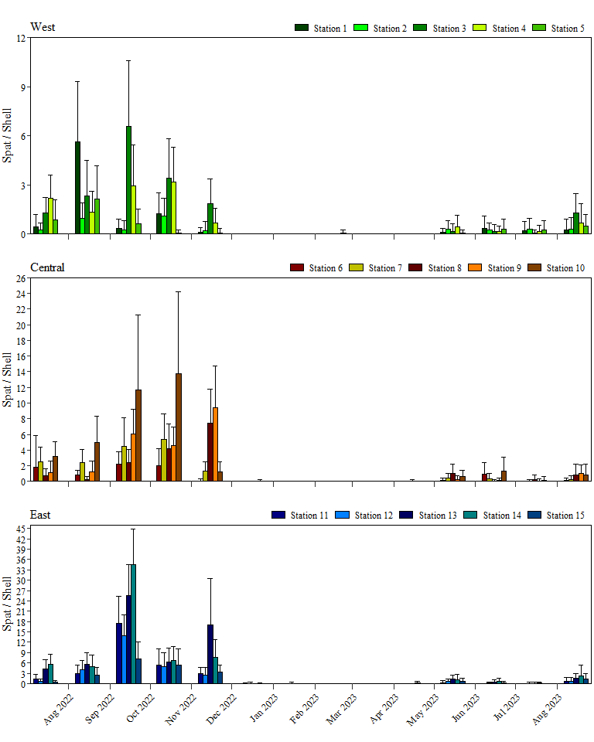

Figure 4. Monthly mean number (± S.D.) of spat (oyster recruits) per shell collected at stations in the West, Central, and East sections of Apalachicola Bay over the past fifteen months (five quarters).

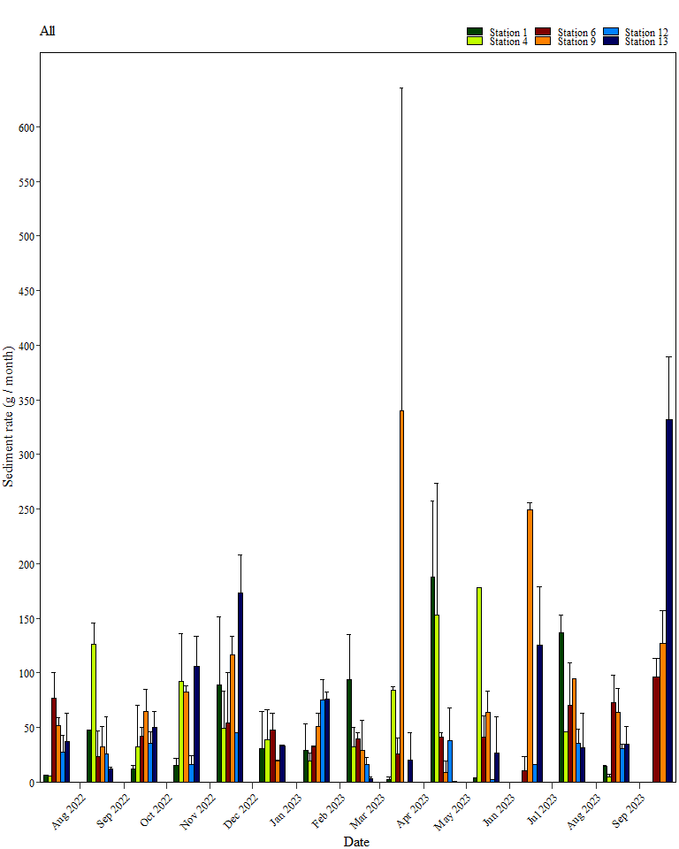

Figure 5. Monthly mean grams (± S.D.) of sediment per trap per month collected at stations in Apalachicola Bay over the past fifteen months (five quarters).



Figure 6. Mean number (± S.D.) of live oysters present each quarter at each parcel in Apalachicola Bay over the past five quarters.



Figure 7. Mean shell height (± S.D.) of live oysters measured each quarter at each parcel in Apalachicola Bay over the past five quarters.



Figure 8. Mean shell height (± S.D.) of dead oysters measured each quarter at each parcel in Apalachicola Bay over the past five quarters.



Figure 9. Mean number (± S.D.) of live oyster drills present each quarter at each parcel in Apalachicola Bay over the past five quarters.





Figure 10. Mean weight (kg / m² ± S.D.) from ¼-m2 quadrats collected each quarter at each parcel in Apalachicola Bay over the past five quarters.

Figure 11. Mean weight (kg / m² ± S.D.) of component parts from ¼-m2 quadrats collected in the Summer 2022 quarter at each parcel in Apalachicola Bay.

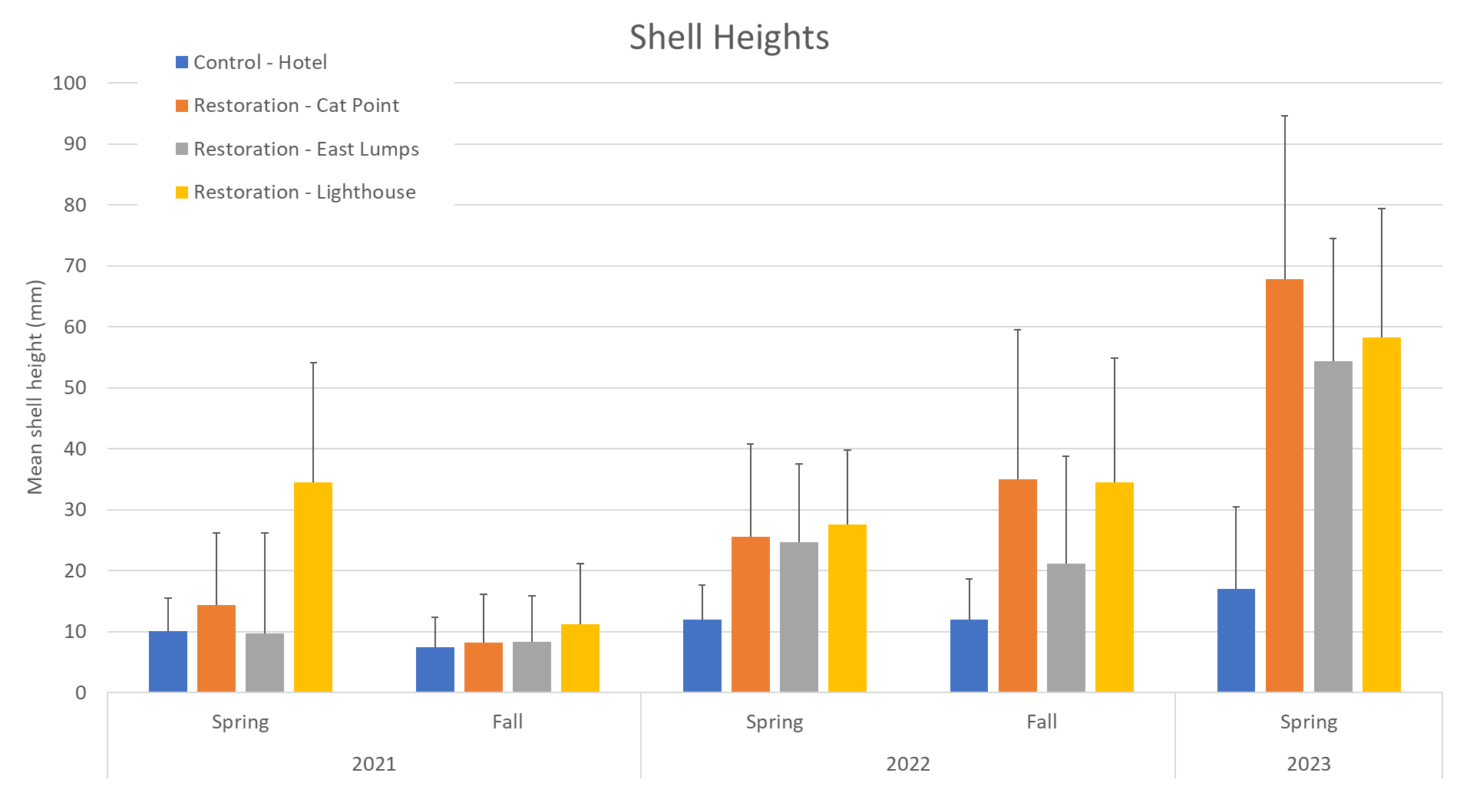Figure 12. Shell heights on the parcels restored in 2021.

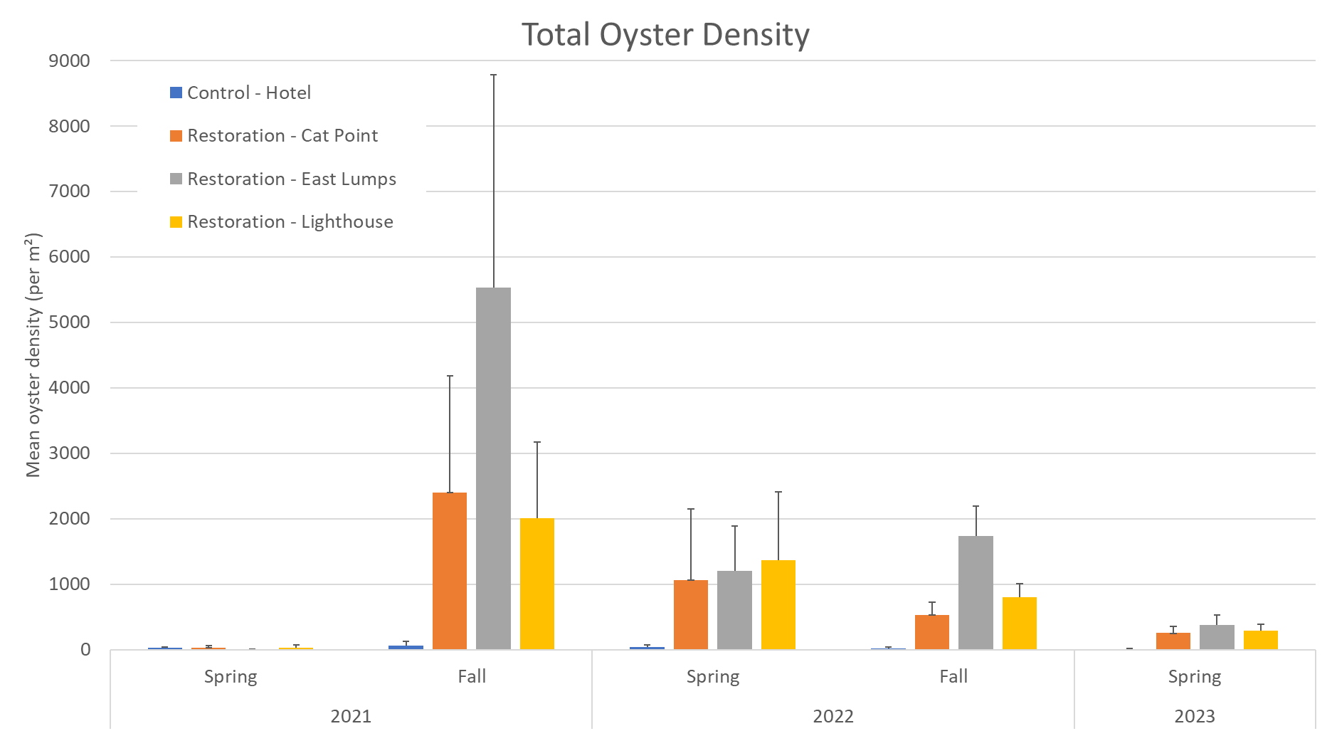

Figure 13. Oyster density on the parcels restored in 2021.

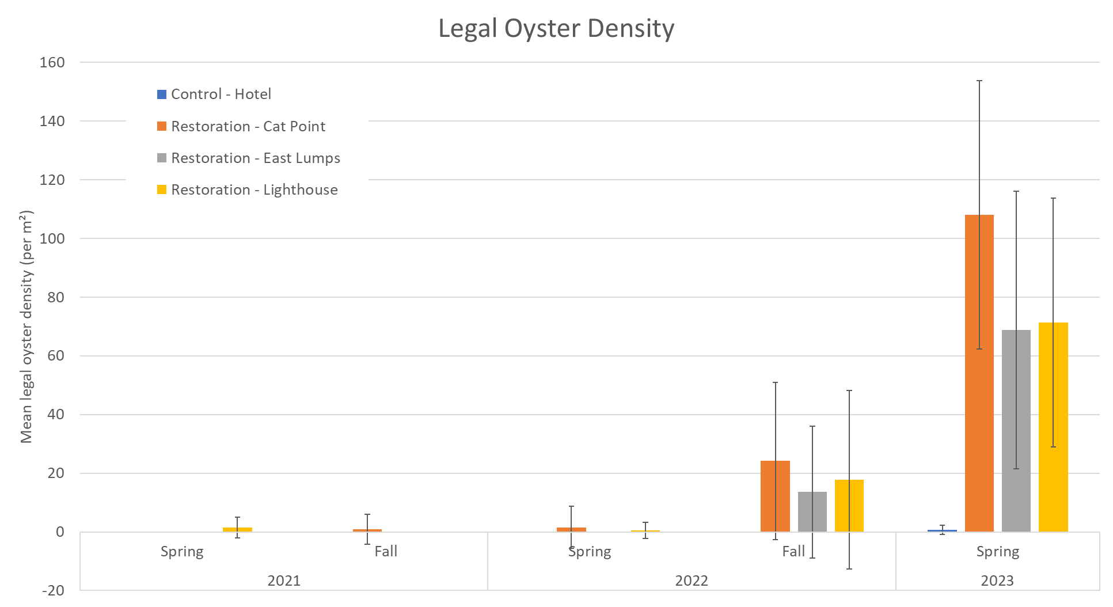

Figure 14. Legal oyster density on the parcels restored in 2021.

Figure 15. Components of shell budgets on the parcels restored in 2021.

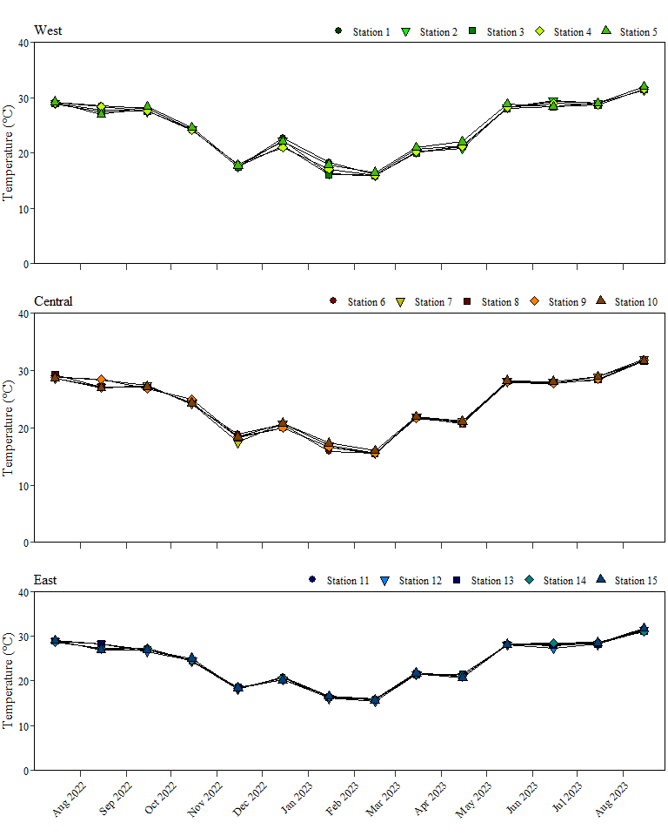

Figure 16. Monthly mean temperature at recruitment and sedimentation monitoring stations in the West, Central, and East sections of Apalachicola Bay over the past fifteen months (five quarters).

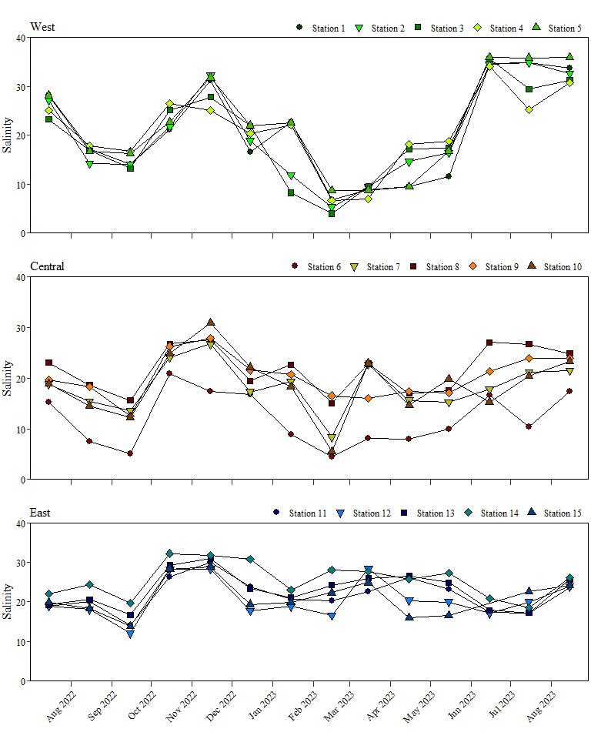

Figure 17. Monthly mean salinity at recruitment and sedimentation monitoring stations in the West, Central, and East sections of Apalachicola Bay over the past fifteen months (five quarters).

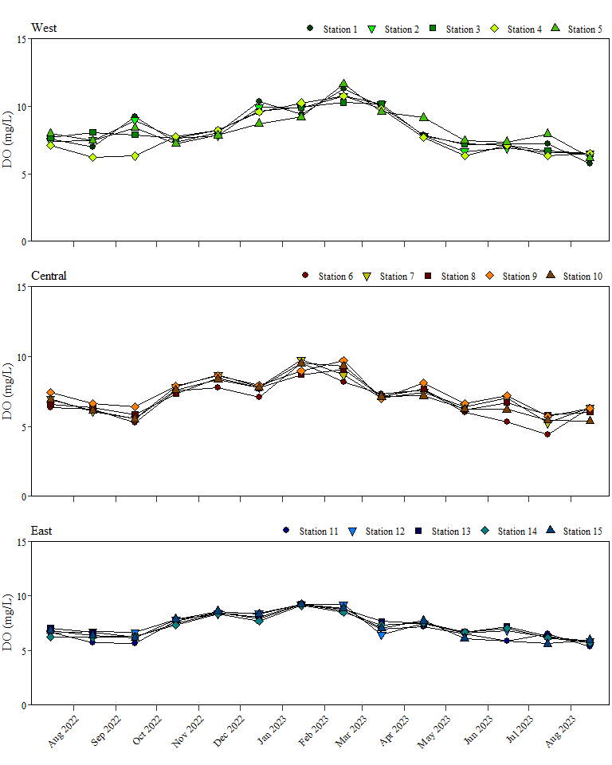

Figure 18. Monthly mean dissolved oxygen (DO) concentration at recruitment and sedimentation monitoring stations in the West, Central, and East sections of Apalachicola Bay over the past fifteen months (five quarters).

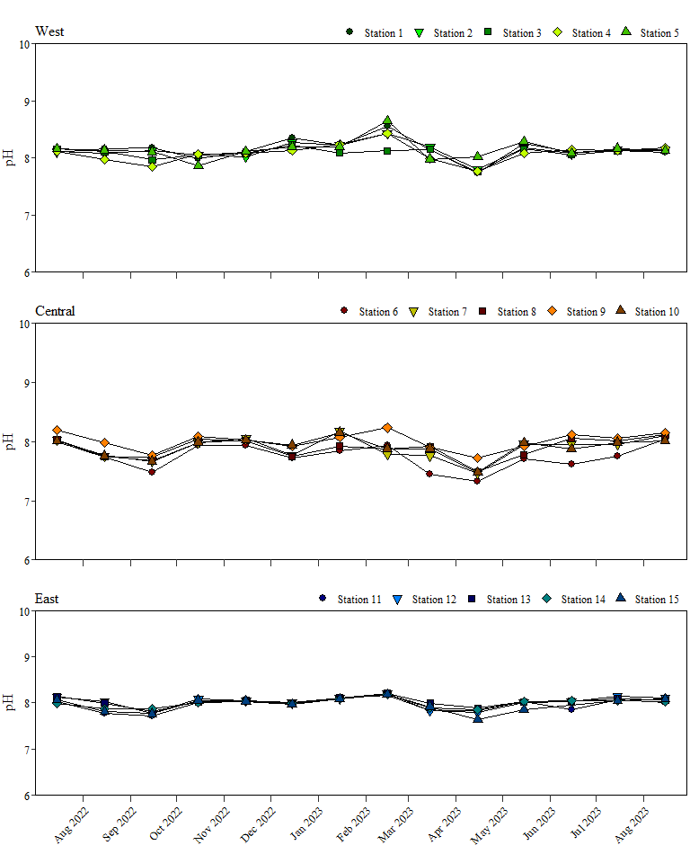

Figure 19. Monthly mean pH at recruitment and sedimentation monitoring stations in the West, Central, and East sections of Apalachicola Bay over the past fifteen months (five quarters).

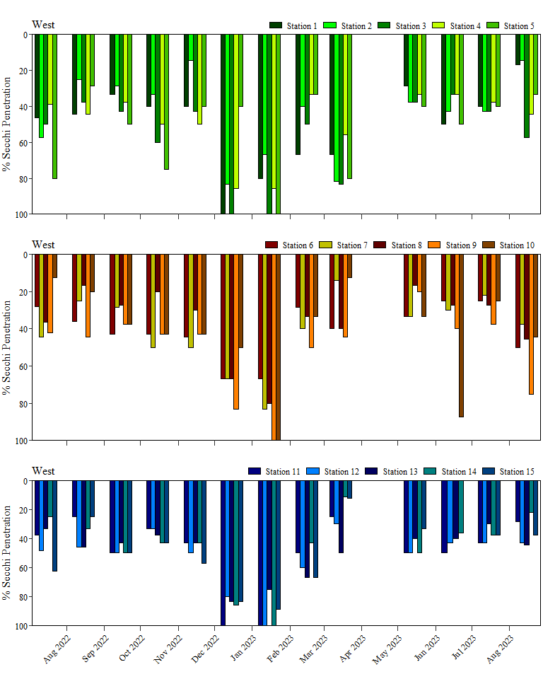

Figure 20. Monthly mean Secchi penetration (percentage of water depth through which the Secchi disk could be seen) at recruitment and sedimentation monitoring stations in the West, Central, and East sections of Apalachicola Bay over the past fifteen months (five quarters).

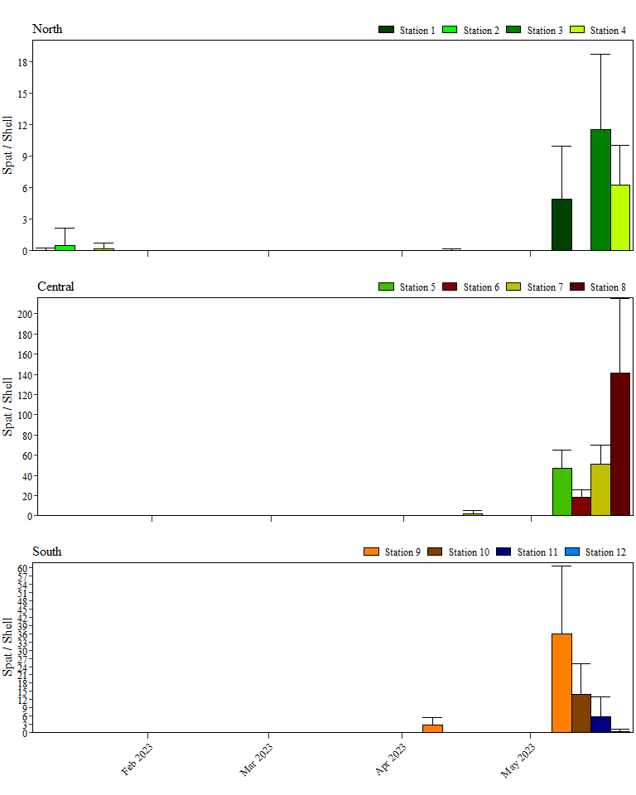

Figure 21. Monthly mean number (± S.D.) of spat (oyster recruits) per shell collected at stations in the North, Central, and South sections of Suwannee Sound in 2023.

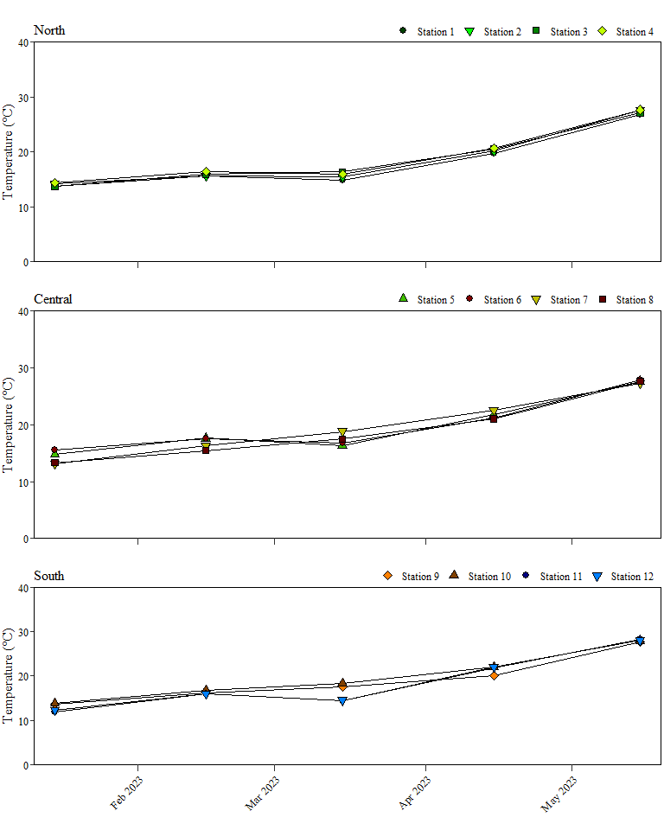

Figure 22. Monthly mean temperature at recruitment stations in the North, Central, and South sections of Suwannee Sound in 2023.

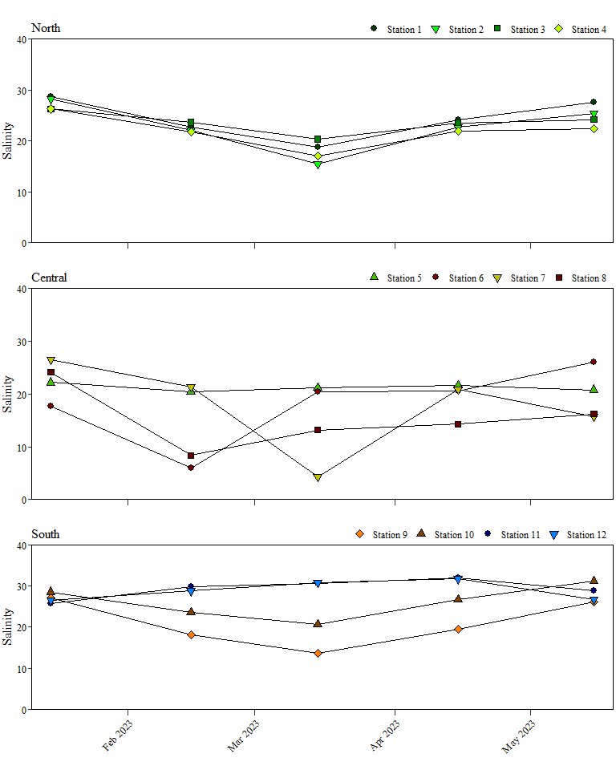

Figure 23. Monthly mean salinity at recruitment monitoring stations in the North, Central, and South sections of Suwannee Sound in 2023.

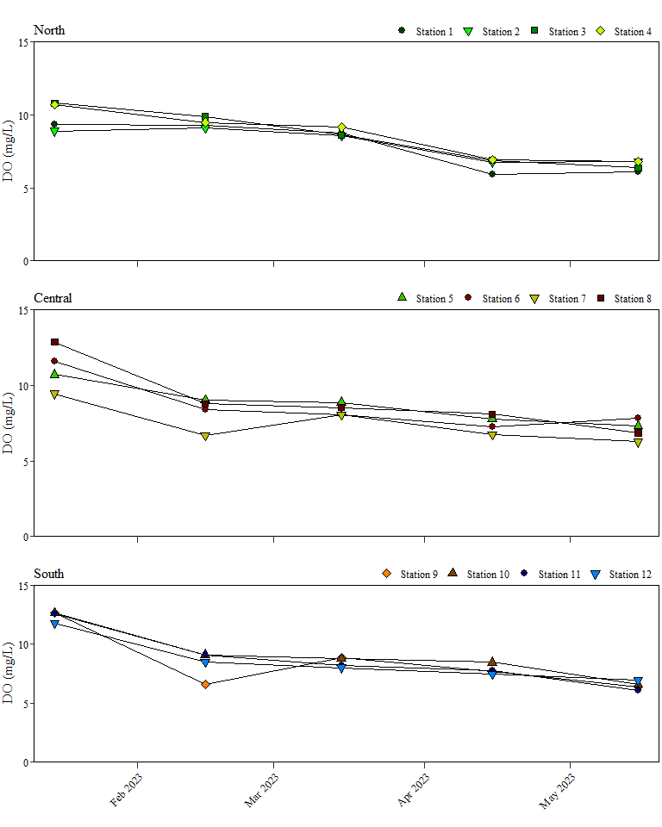

Figure 24. Monthly mean dissolved oxygen (DO) concentration at recruitment monitoring stations in the North, Central, and South sections of Suwannee Sound in 2023.

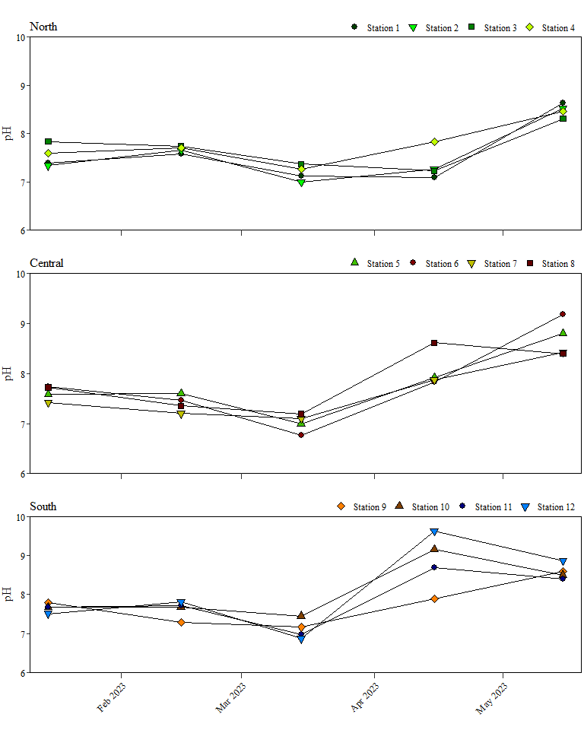

Figure 25. Monthly mean pH at recruitment monitoring stations in the North, Central, and South sections of Suwannee Sound in 2023.